**Library Management System**

**Introduction**

Library management system is a project which aims in developing a computerized system to maintain all the daily work of library. This project has many features which are generally available in normal library management systems like facility of user login.

It also has a facility of admin login through which the admin can monitor the whole system. It also has facility of an online notice board where teachers can student can put up information about workshops or seminars being held in our colleges or nearby colleges and librarian after proper verification from the concerned institution organizing the seminar can add it to the notice board. It has also a facility where student after logging in their accounts can see list of books issued and its issue date and return date and also the students can request the librarian to add new books by filling the book request form. The librarian after logging into his account i.e. admin account can generate various reports such as student report, issue report, teacher report and book report.

**SYSTEM OBJECTIVES**

• Improvement in control and performance: The system is developed to cope up with the current issues and problems of library.The system can add user, validate user and is also bug free.

•Save cost: After computerized system is implemented less human force will be required to maintain the library thus reducing the overall cost.

• Save time: Librarian is able to search record by using few clicks of mouse and few search keywords thus saving his valuable time.

•Option of online Notice board: Librarian will be able to provide a detailed description of workshops going in the college as well as in nearby colleges

**SYSTEM REQUIREMENTS**

**NON FUNCTIONAL REQUIREMENTS**

Product Requirements

EFFICIENCY

When a library management system will be implemented librarian and user will easily acess library as searching and book transaction will be very faster.

RELIABILITY

The system should accurately perform member registration, member validation, report generation, book transaction and search

USABILITY REQUIREMENT

The system is designed for a user friendly environment so that student and staff of library can perform the various tasks easily and in an effective way.

**FUNCTIONAL REQUIREMENTS**

1. NORMAL USER

1.1 USER LOGIN :

Description of feature

This feature used by the user to login into system. They are required to enter user id and

password before they are allowed to enter the system .The user id and password will be verified

and if invalid id is there user is allowed to not enter the system.

Requirements

- user id is provided when they register

- The system must only allow user with valid id and password to enter the system

- The system performs authorization process which decides what user level can acess to.

- The user must be able to logout after they finished using system.

1.2 REGISTER NEW USER

Description of feature

This feature can be performed by all users to register new user to create account.

Requirements

- System must be able to verify information

- System must be able to delete information if information is wrong

1.3 REGISTER NEW BOOK

Description of feature

This feature allows to add new books to the library

Requirements

- System must be able to verify information

- System must be able to enter number of copies into table.

- System must be able to not allow two books having same book id

1.4 SEARCH BOOK

Description Of Feature

This feature is found in book maintenance part. we can search book based on book id, book name , publication or by author name.

Requirements

- System must be able to search the database based on select search type

- System must be able to filter book based on keyword entered

- System must be able to show the filtered book in table view

1.5 ISSUE BOOKS AND RETURN BOOKS

Description Of Feature

This feature allows to issue and return books and also view reports of book issued.

Requirements

- System must be able to enter issue information in database.

- System must be able to update number of books.

- System must be able to search if book is available or not before issuing books

- System should be able to enter issue and return date information

1.6 EVENT ADDITION

Description Of Feature

This feature allows teacher and student to add information about various workshops being

conducted in college and colleges nearby

Requirements

- System should be able to add detailed information about events .

- System should be able to display information on notice board available in the homepage of

site

2. ADMIN USER

2.1 USER LOGIN :

Description of feature

This feature used by the admin to login into system. They are required to enter user id and

password before they are allowed to enter the system .The user id and password will be verified

and if invalid id is there user is allowed to not enter the system.

Requirements

- user id is provided when they register

- The system must only allow user with valid id and password to enter the system

- The system performs authorization process which decides what user level can access to.

- The admin must be able to logout after they finished using system.

… Similarly add more features of the admin as required

**CONSTRAINTS**

IMPLEMENTATION REQUIREMNTS

In implementing whole system it uses html in front end with php as server side scripting language which will be used for database connectivity and the backend ie the database part is developed using mysql.

DELIVERY REQUIREMENTS

The whole system is expected to be delivered in six months of time with a weekly

evaluation by the project guide

SOFTWARE AND HARDWARE REQUIREMENTS

This section describes the software and hardware requirements of the system

SOFTWARE REQUIREMENTS

• Operating system

- Windows is used as the operating system as it is stable and supports more features and is more user friendly

• Database MYSQL

- MYSQL is used as database as it easy to maintain and retrieve records by simple queries which are in English language which are easy to understand and easy to write.

• Development tools and Programming language

- HTML is used to write the whole code and develop webpages with css, java script for styling work and php for sever side scripting.

HARDWARE REQUIREMENTS

¬ Intel core i5 2nd generation is used as a processor because it is fast than other

processors and provide reliable and stable and we can run our pc for longtime.

By using this processor we can keep on developing our project without any

worries.

¬ Ram 1 gb is used as it will provide fast reading and writing capabilities and

will in turn support in processing

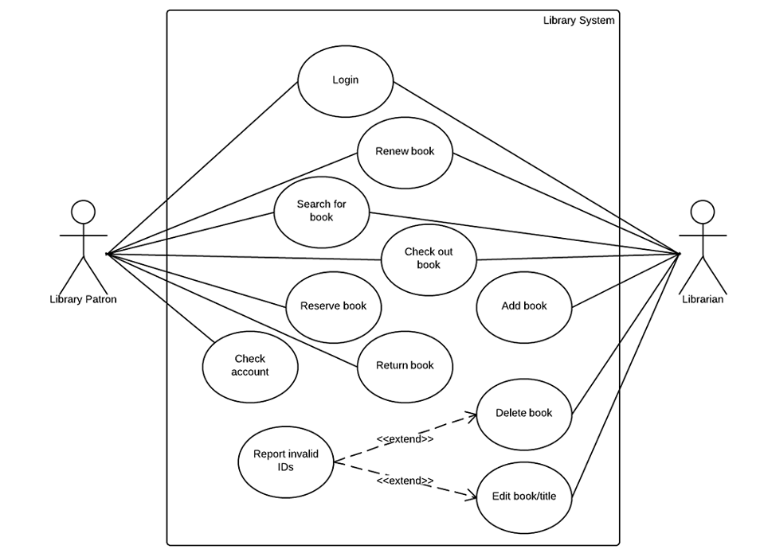

Figure 1: Use case diagram for library management system